Pf lab #6 Assignment

Mohammad Yehya , 21k-3309

Table of Contents

**Question #1:** 2

**Question #2:** 3

**Question #3:** 4

**Question #4:** 6

**Question #5:** 8

**Question #6:** 9

**Question #7:** 10

**Question #8:** 11

# **Question #1:**

#include <stdio.h>

int main()

{

//Q1

int num;

do

{

printf("Please enter a 2 digit number: ");

scanf("%d",&num);

}

while (num<0 || num>100);

if ((num/10+num%10)%9==0)

{

printf("%d is divisible by 9",num);

}

else

{

printf("%d is not divisble by 9",num);

}

}

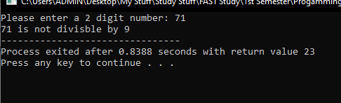

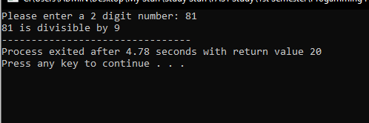

# **Question #2:**

#include <stdio.h>

int main()

{

//Q2

float s1,s2,s3;

printf("Please enter the sides of the triangle.");

printf("\nSide1: ");

scanf("%f",&s1);

printf("Side2: ");

scanf("%f",&s2);

printf("Side3: ");

scanf("%f",&s3);

if (s1 == s2 && s2 == s3 && s1 == s3)

{

printf("It is an equilateral triangle!");

}

else if ((s1 == s2 && s2 != s3) || (s1 == s3 && s3 != s2) || (s2 == s3 && s1 != s2))

{

printf("It is an isosceles triangle!");

}

else

{

printf("It is a scalene triangle!");

}

}

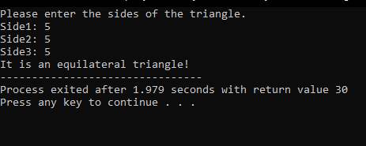

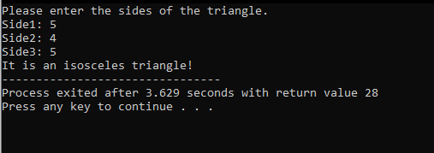

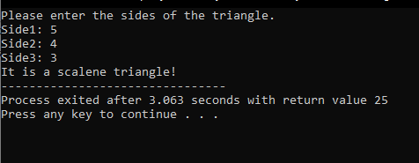

# **Question #3:**

#include <stdio.h>

int main()

{

//Q3

float totcal,fatgrms,fatcal;

do

{

printf("Please enter fat grams: ");

scanf("%f",&fatgrms);

printf("Please enter total calories: ");

scanf("%f",&totcal);

}

while (fatgrms < 0 || totcal < 0);

fatcal = fatgrms * 9;

if (fatcal > totcal)

{

printf("Invalid Input! Inputs were entered incorrectly!");

}

else

{

printf("The percentage of calories from fat is %f", fatcal/totcal*100);

if (fatcal/totcal*100 < 30)

{

printf("\nFood is low on fat.");

}

}

}

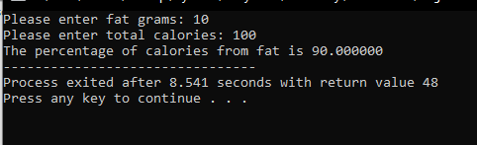

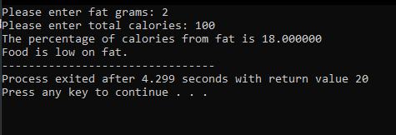

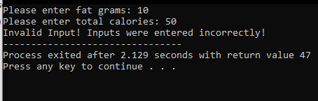

# **Question #4:**

#include <stdio.h>

int main()

{

//Q4

int score,deduction;

printf("Please enter your score: ");

scanf("%d",&score);

switch(score)

{

case 95 ... 100:

deduction = 15;

printf("Your fee is reduced by %d percent.",deduction);

break;

case 90 ... 94:

deduction = 10;

printf("Your fee is reduced by %d percent.",deduction);

break;

case 80 ... 89:

deduction = 8;

printf("Your fee is reduced by %d percent.",deduction);

break;

case 70 ... 79:

deduction = 4;

printf("Your fee is reduced by %d percent.",deduction);

break;

default:

printf("You have no deduction in fees.");

}

}

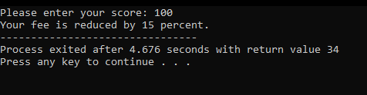

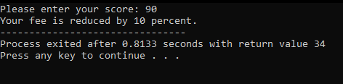

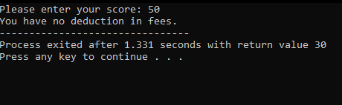

# **Question #5:**

#include <stdio.h>

int main()

{

int num1=0,num2=0;

if(!num1 && !num2)

{

printf("True");

}

if (!num1 && num2){}

else

{

printf("\nFalse");

}

if (num1 || !num2)

{

printf("\nTrue");

}

}

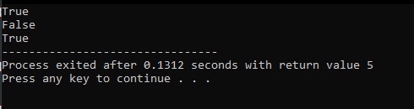

# **Question #6:**

#include <stdio.h>

int main()

{

//Q6

char type;

printf("Please enter your prefered type of coffee: ");

scanf("%c",&type);

switch(type)

{

case 'B':

printf("Put Water\t20 mins\nSugar\t\t20 mins\nMix Well\t25 mins\nAdd Coffee\t15 mins\nAdd Milk\t -\nMix Well\t25 well");

break;

case 'W':

printf("Put Water\t15 mins\nSugar\t\t15 mins\nMix Well\t20 mins\nAdd Coffee\t2 mins\nAdd Milk\t4 mins\nMix Well\t20 mins");

break;

default:

printf("Please enter either B or W");

}

}

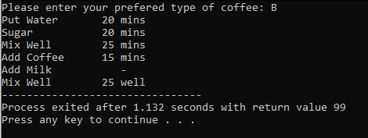

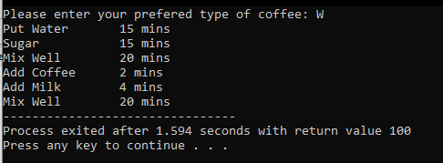

# **Question #7:**

#include <stdio.h>

int main()

{

//Q7

int num1,num2,num3;

printf("Enter number 1: ");

scanf("%d",&num1);

printf("Enter number 2: ");

scanf("%d",&num2);

printf("Enter number 3: ");

scanf("%d",&num3);

if (num1 >= num2)

{

if (num1>=num3)

{

printf("%d",num1);

}

else

{

printf("%d",num3);

}

}

else

{

if (num2 >= num3)

{

printf("%d",num2);

}

else

{

printf("%d",num3);

}

}

}

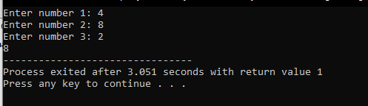

# **Question #8:**

#include <stdio.h>

int main()

{

int types,amount4=0,amount3=0,amount2=0,amount1=0,flag=1,total=0;

char choice4,choice3,choice2,choice1;

printf("\t\t\t\t\tABC Restaurant Online Order Placement\n\t\t\t\t\t\t\tWELCOME!\nPlease select from the following Menu");

printf("\nB = Burger\t\tRs.200\nF = French Fries\tRs.50\nP = Pizza\t\tRs.500\nS = Sandwiches\t\tRs.150");

printf("\nHow many types of snacks you need to order: ");

scanf("%d",&types);

switch(types) // Purposely didn't add break so that if the user enters 4 it would do 4 times and if the user enter 3 it would do 3 times and so on.

{

case 4:

printf("Enter type of snack you want to order: ");

scanf(" %c",&choice4);

printf("Please provide quantity: ");

scanf("%d",&amount4);

case 3:

printf("Enter type of snack you want to order: ");

scanf(" %c",&choice3);

printf("Please provide quantity: ");

scanf("%d",&amount3);

case 2:

printf("Enter type of snack you want to order: ");

scanf(" %c",&choice2);

printf("Please provide quantity: ");

scanf("%d",&amount2);

case 1:

printf("Enter type of snack you want to order: ");

scanf(" %c",&choice1);

printf("Please provide quantity: ");

scanf("%d",&amount1);

break;

default:

printf("You can only enter a maximum of 4 types!");

flag = 0;

break;

}

if (flag == 1)

{

printf("------------------------------------------\nYou have ordered!\n");

switch (types)

{

case 4:

if (choice4 == 'B')

{

printf("%d Burger (s) value %d PKR",amount4,amount4*200);

total = total + amount4*200;

}

else if (choice4 == 'F')

{

printf("%d French Fries value %d PKR",amount4,amount4*50);

total = total + amount4*50;

}

else if (choice4 == 'P')

{

printf("%d Pizza (s) value %d PKR",amount4,amount4*500);

total = total + amount4*500;

}

else if (choice4 == 'S')

{

printf("%d SandWich (s) value %d PKR",amount4,amount4*150);

total = total + amount4*150;

}

case 3:

if (choice3 == 'B')

{

printf("\n%d Burger (s) value %d PKR",amount3,amount3*200);

total = total + amount3*200;

}

else if (choice3 == 'F')

{

printf("\n%d French Fries value %d PKR",amount3,amount3*50);

total = total + amount3*50;

}

else if (choice3 == 'P')

{

printf("\n%d Pizza (s) value %d PKR",amount3,amount3*500);

total = total + amount3*500;

}

else if (choice3 == 'S')

{

printf("\n%d SandWich (s) value %d PKR",amount3,amount3*150);

total = total + amount3*150;

}

case 2:

if (choice2 == 'B')

{

printf("\n%d Burger (s) value %d PKR",amount2,amount2*200);

total = total + amount2*200;

}

else if (choice2 == 'F')

{

printf("\n%d French Fries value %d PKR",amount2,amount2*50);

total = total + amount2*50;

}

else if (choice2 == 'P')

{

printf("\n%d Pizza (s) value %d PKR",amount2,amount2*500);

total = total + amount2*500;

}

else if (choice2 == 'S')

{

printf("\n%d SandWich (s) value %d PKR",amount2,amount2*150);

total = total + amount2*150;

}

case 1:

if (choice1 == 'B')

{

printf("\n%d Burger (s) value %d PKR",amount1,amount1*200);

total = total + amount1*200;

}

else if (choice1 == 'F')

{

printf("\n%d French Fries value %d PKR",amount1,amount1*50);

total = total + amount1*50;

}

else if (choice1 == 'P')

{

printf("\n%d Pizza (s) value %d PKR",amount1,amount1*500);

total = total + amount1*500;

}

else if (choice1 == 'S')

{

printf("\n%d SandWich (s) value %d PKR",amount1,amount1*150);

total = total + amount1*150;

}

}

printf("\nTotal: %d\nThank you for your order... have a nice day.",total);

}

}

